The Roman Catholic Federation of Holy Name and Our Lady’s

Charging and Remissions Policy

HOLY NAME MISSION STATEMENT

The Holy Name Primary School is a voluntary aided, inclusive, Roman Catholic School serving the children of the Our Lady’s with St Alphonsus and neighbouring parishes.

The school exists to help the Catholic Community fulfil the promise made to each child when welcomed in Baptism by the promotion of Catholic values in school. This is undertaken in partnership within the home and parish.

Recognising the variety of children’s backgrounds, the Governors and staff seek to be sensitive to and cater for their individual needs. We work to create a safe and secure environment with consistency, tolerance and generosity of time for all members of our school community.

We emphasise the positive aspects of all parts of school life, teaching the children about their value and worth and at the same time having high expectations in relation to academic and personal development.

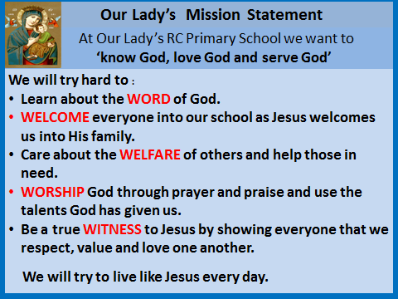

At Our Lady’s, we seek at all times to be a witness to Jesus Christ. We remember this when putting our policies into practice.

The Roman Catholic Federation of Holy Name and Our Lady’s

Policy on Charging and Remissions

The governors note the requirements of the 1996 Education act and
the DFE Guidance Oct 2014, Charging for School Activities. The
governors agree that:

1. Introduction

1.1 All education during school hours is free. We do not charge for any
activity undertaken as part of the National Curriculum.

2. Voluntary contributions

2.1 When organising school trips or visits which enrich the curriculum and
educational experience of the children, the school invites parents to
contribute to the cost of the trip. All contributions are voluntary. If we do not
receive sufficient voluntary contributions, we may cancel a trip. If a trip goes
ahead, it may include children whose parents have not paid any
contribution. We do not treat these children differently from any others. The
school may use some of the Pupil Premium Allocation to ensure all children
attend trips.

2.2 If a parent wishes their child to take part in a school trip or event, but is
unwilling or unable to make a voluntary contribution, we allow the child to
participate fully in the trip or activity. Sometimes the school pays additional
costs in order to support the visit. Parents have a right to know how each trip is funded. The school provides this information on request.
2.3 The following is a list of additional activities organised by the school, which
require voluntary contributions from parents. These activities are known as
‘optional extras’. This list is not exhaustive:

•visits to museums
•sporting activities which require transport expenses
•outdoor adventure activities
•visits to the theatre
•school trips
•musical events

3. Residential visits

3.1 If the school organises a residential visit in school time or mainly school
time, which is to provide education directly related to the National
Curriculum, we do not make any charge for the education. However, we do
make a charge to cover the costs of board, lodging and travel expenses. If
parents are experiencing financial difficulty they are invited to write in
confidence to the Head of School

4. Music tuition

4.1 All children study music as part of the normal school curriculum. We do not charge for this.

4.2 There is no charge for individual or group music tuition if this is part of the
National Curriculum. The peripatetic music teachers teach individual or small
group lessons.

5. Swimming

5.1 The school organises swimming lessons for all children in Year 4. These take
place in school time and are part of the National Curriculum. We make no
charge for this activity. We inform parents when these lessons are to take
place.

The head teacher is permitted to contribute to the costs of an activity from
any funds that may be available.

